Name: Sally Phan
Year: 10

Double Exposure – Woman and Red flowers
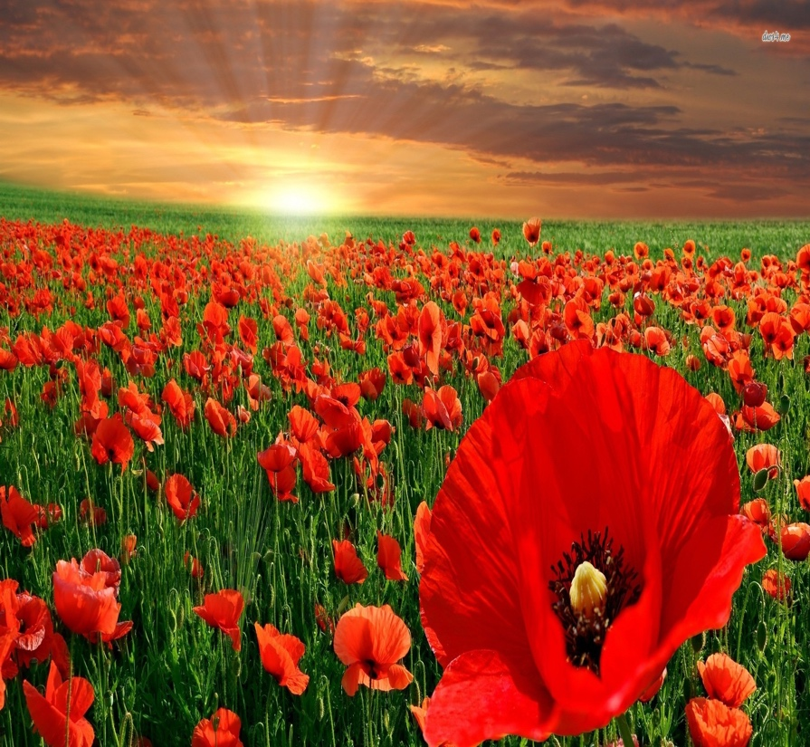

Step 1:

- Open her image in Photoshop.
- Select Quick Selection Tool to select around her, double click on her layer and then Ok. Click on the Layer Mask to get a new layer mask.
- Create new layer put it under the mother layer and fill it white.

Step 2:

- Open the red flower in Photoshop and Cmd + A, Cmd + C to copy it then go back the woman layer Cmd + V.
- Cmd + T to turn it around and make it bigger size I want. Click on the woman layer Cmd + T to make it smaller and higher.
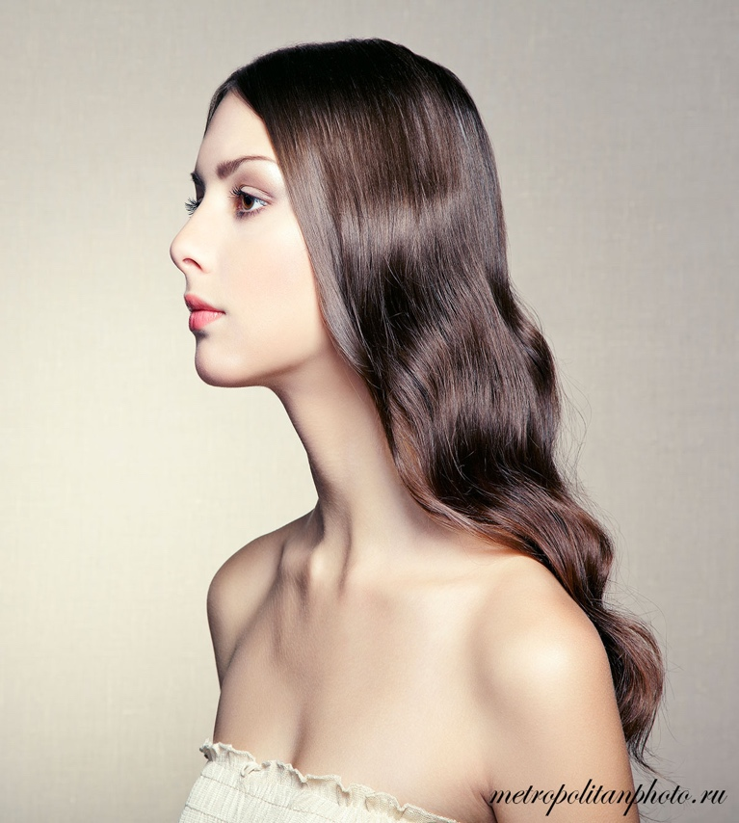
- Change Normal to Lighten.

Step 3:

- Cmd + Click on her layer to select her and go Select -> Inverse. Use the normal Brush to cut out the the flower I do not want it.
- Copy her layer and delete the layer mask then create the new one and fill it black by Alt + Delete. Use the Brush but make sure the colour is white and select around her face where I want to see probably.

Step 4:

- Make a new layer -> Levels then choice about 20%.
- Make a new layer fill it dark blue the Opacity about 88%, then Levels and make the colour to match with her colour.

Step 5:

- Save it in JPG.

Here we go:

